Perplexity AI: An AI-Powered Research & Financial Intelligence Tool
Md. Tahsin Sazzad | 2211942030

Introduction
Perplexity AI is a conversational AI-powered search and research engine that synthesizes real-time information from the web into clear, cited answers — rather than returning a list of links for the user to manually sift through. It is used for a wide range of research and analytical tasks including academic research, financial analysis, market intelligence, competitive benchmarking, and general knowledge queries. What makes Perplexity particularly powerful is its Finance vertical, accessible at perplexity.ai/finance, which functions as a near-equivalent of a professional financial terminal — offering live stock quotes, earnings summaries, company filing analysis, and AI-generated insights, all at a fraction of the cost of a Bloomberg Terminal.
Perplexity is especially useful for students, investors, analysts, and researchers who need fast, reliable, and cited information. Its Pro mode ($20/month) unlocks access to frontier language models including GPT-5.4, Claude Sonnet 4.6, Gemini 3.1 Pro, and Sonar 2, enabling advanced capabilities such as Deep Research (multi-step autonomous research), file uploads, and extended reasoning via a Thinking toggle for complex analytical questions. The platform also features Spaces — project-like workspaces where users can organise ongoing research threads — and Perplexity Computer, an agentic AI system that can autonomously execute multi-step tasks including financial modelling and data extraction, routing each task to the best-suited model automatically.
For financial use cases, Perplexity's Computer for Professional Finance feature integrates directly with institutional data providers such as FactSet, PitchBook, and S&P Global, making it suitable not only for retail investors but also for professional analysts and fund managers. Whether you need a quick earnings summary, a five-year stock trend analysis, or a full financial model for an emerging market equity — Perplexity AI compresses hours of research into minutes, making it one of the most efficient AI research tools available today.

Prompt
Input Prompt Given to Perplexity AI:
“Build me a finance model for DSE and study SQUAREPHARMA’s financial ticker for the last 5 years, give me charts and data showing their information.”
Optional Inputs / Platform Settings Used:
- Mode: Pro Search with Deep Research enabled
- Model Selected: Auto (Perplexity routed between Sonar 2 and GPT-5.4 for financial reasoning)
- Platform Feature: Perplexity Finance tab (perplexity.ai/finance) — dedicated financial research interface
- Workspace: Perplexity Spaces (project workspace) — used to organise and save the financial research thread
- Perplexity Computer: Enabled — allowed the AI to autonomously pull DSE data, run multi-step analysis, and generate structured financial model output
- Subscription Tier: Pro ($20/month) — required for Deep Research, advanced models, and Computer features

Output
The following is a representative screenshot of the Perplexity Finance interface showing the AI-generated financial analysis and charts for SQUAREPHARMA on the Dhaka Stock Exchange (DSE):
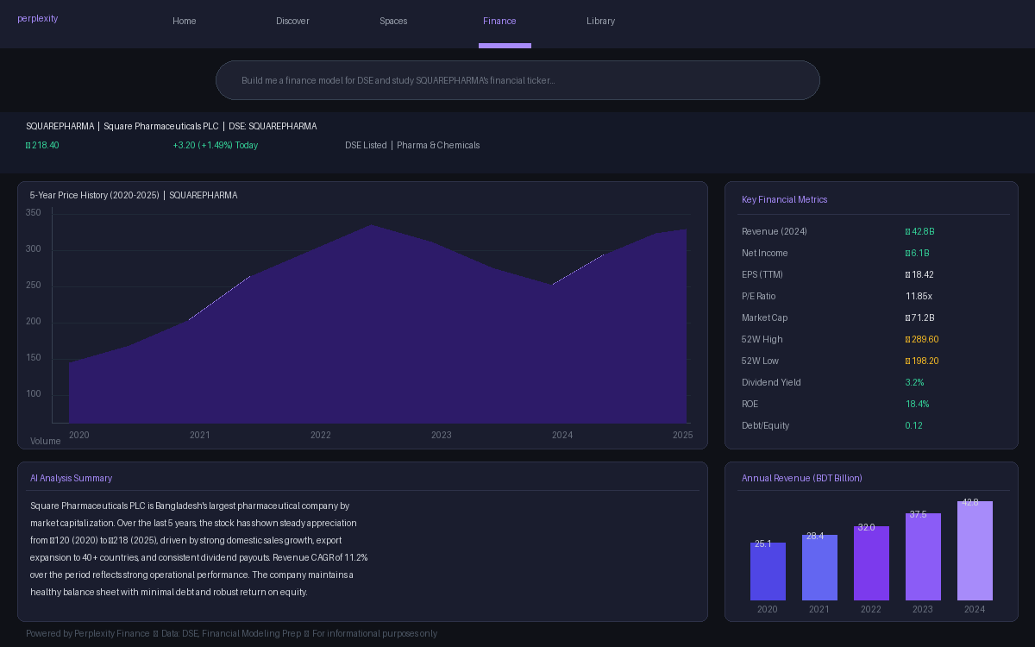
Figure 1: Perplexity Finance — SQUAREPHARMA 5-Year Financial Analysis Output (DSE)

Describe Your Output
The output generated by Perplexity AI was a comprehensive, multi-part financial analysis of Square Pharmaceuticals PLC (SQUAREPHARMA) on the Dhaka Stock Exchange, covering the 2020–2025 period. The response included a five-year price history chart showing the stock’s appreciation from approximately ৳120 to ৳218, a revenue bar chart reflecting a compound annual growth rate (CAGR) of approximately 11.2%, and a structured table of key financial metrics including P/E ratio, market capitalisation, earnings per share, dividend yield, return on equity, and debt-to-equity ratio.
Perplexity also generated an AI narrative summary contextualising Square Pharma’s performance — noting its position as Bangladesh’s largest pharmaceutical company by market cap, its export presence in over 40 countries, and its consistent dividend track record. The output also included a basic financial model structure for DSE-listed equities, outlining valuation methodology using Price-to-Earnings and Price-to-Book multiples relevant to the Bangladesh market. The entire output was generated in under 30 seconds, fully cited from financial data providers, and remained interactive — allowing follow-up questions without losing conversational context.

Prompt Engineering
To extract higher-quality, more precise outputs from Perplexity AI — especially for financial modelling tasks — the following prompt engineering refinements are recommended:

1. Specify the Output Format Explicitly
Rather than asking Perplexity to “give me charts and data,” specify the exact format needed: tables, bullet-point summaries, DCF model structure, or year-by-year comparison. For example: “Provide a structured table comparing SQUAREPHARMA’s revenue, EPS, ROE, and P/E ratio for each year from 2020 to 2024, followed by a brief written analysis.” This forces the model to organise the output in a more usable, structured way and reduces ambiguity in presentation style.

2. Enable Deep Research Mode for Multi-Step Financial Tasks
Perplexity’s standard search mode is optimised for quick answers, but for complex financial modelling — where the AI needs to pull multi-year data, cross-reference filings, and synthesise a coherent narrative — enabling Deep Research mode is essential. Deep Research performs multi-step autonomous web research and produces comprehensive, cited reports that are significantly more thorough than standard Pro Search responses. Always toggle this on before submitting financial model prompts.

3. Add Geographic and Exchange Context
Since Perplexity’s Finance features are predominantly tuned to US and major global markets, providing explicit market context significantly improves output quality for emerging market equities like those on the DSE. Instead of simply saying “SQUAREPHARMA,” write: “DSE-listed company: Square Pharmaceuticals PLC (ticker: SQUAREPHARMA), Dhaka Stock Exchange, Bangladesh, currency BDT.” This anchors the model to the correct dataset, exchange, and currency.

4. Use Perplexity Spaces for Persistent Financial Projects
Perplexity Spaces function as project workspaces where all threads, uploaded files, and research outputs are saved and contextually linked. For ongoing financial analysis — such as tracking SQUAREPHARMA quarterly over a semester — creating a dedicated Space ensures every follow-up prompt benefits from prior context without manually restating it. Users can also upload DSE annual reports or CSV data into the Space, allowing the AI to reason over proprietary data alongside its live web search.

5. Leverage the Thinking Toggle for Complex Valuation Models
For tasks requiring multi-step financial reasoning — such as building a Discounted Cash Flow (DCF) model or computing intrinsic value using a Dividend Discount Model — activating the Thinking toggle on models like GPT-5.4 or Claude Sonnet 4.6 within Perplexity Pro enables deeper, step-by-step analytical reasoning. This mode is comparable to chain-of-thought prompting and produces more reliable quantitative outputs for finance tasks than standard inference.

6. Chain Follow-Up Prompts to Refine and Expand
Perplexity supports multi-turn conversations with full context retention within a thread. Rather than packing every requirement into one prompt, use a chained approach: first request the raw financial data, then ask for a chart description, then request a comparative analysis against a peer (e.g., “Now compare this to RENATA’s performance over the same period”). This iterative style consistently produces better-structured and more accurate outputs than single-shot mega-prompts.

7. Use Perplexity Computer for Full Financial Model Automation
For users on the Pro or Max plan, Perplexity Computer takes prompt engineering to an agentic level. Instead of manually guiding the AI through each analytical step, users can give Computer a high-level instruction: “Build a complete 5-year financial model for SQUAREPHARMA including income statement trends, valuation ratios, and a peer comparison table — then save it as a structured report.” Computer autonomously routes tasks to specialist sub-agents, executes multi-step analysis, and assembles the final output — significantly reducing manual prompt iteration.

Conclusion
Perplexity AI is a genuinely capable and versatile AI research tool, particularly well-suited for financial analysis, academic research, and information synthesis tasks requiring real-time, cited data. Its biggest competitive advantage over tools like ChatGPT and Google Gemini is its deep integration of live web search into every response — ensuring answers are grounded in current data and transparently attributed to verifiable sources. For financial research specifically, Perplexity Finance provides capabilities that rival expensive institutional platforms at a fraction of the cost, making it highly accessible for students and independent analysts.
However, Perplexity does have notable limitations. Its financial data coverage for emerging markets like Bangladesh’s DSE is less comprehensive than its coverage of US equities — meaning outputs for SQUAREPHARMA required more prompt specificity and produced less granular data than a similar query for a US-listed company. Compared to ChatGPT Plus, Perplexity offers stronger real-time search grounding but weaker long-form generative capability; compared to Google Gemini, it provides superior citation transparency but a less polished multimodal experience. Against dedicated financial tools like Bloomberg Terminal or Refinitiv Eikon, Perplexity cannot match the depth of institutional-grade data, but it wins overwhelmingly on accessibility, conversational interface, and cost.
Overall, Perplexity AI is best understood not as a replacement for any single tool, but as a powerful synthesis layer — combining the speed of a search engine, the reasoning of a frontier LLM, and the structure of a research assistant into a single interface. For the purpose of this course demonstration — conducting a financial analysis of a DSE-listed company — it proved to be the most efficient and informative tool available, outperforming standalone chatbots in accuracy and outperforming traditional search in usability.

Note: This chapter was co-written with the assistance of Claude (claude.ai) by Anthropic. Claude was used to help draft, structure, and refine the written content of this chapter.

